VOCATIONS IRELAND AUTUMN CONFERENCE
NOVEMBER 7TH 2020 VIA ZOOM 2P.M.-5.00P.M.

How to Reimagine the Future of Religious Life.

The speaker is Sr Carol Zinn SSJ
Executive Director of LCWR.

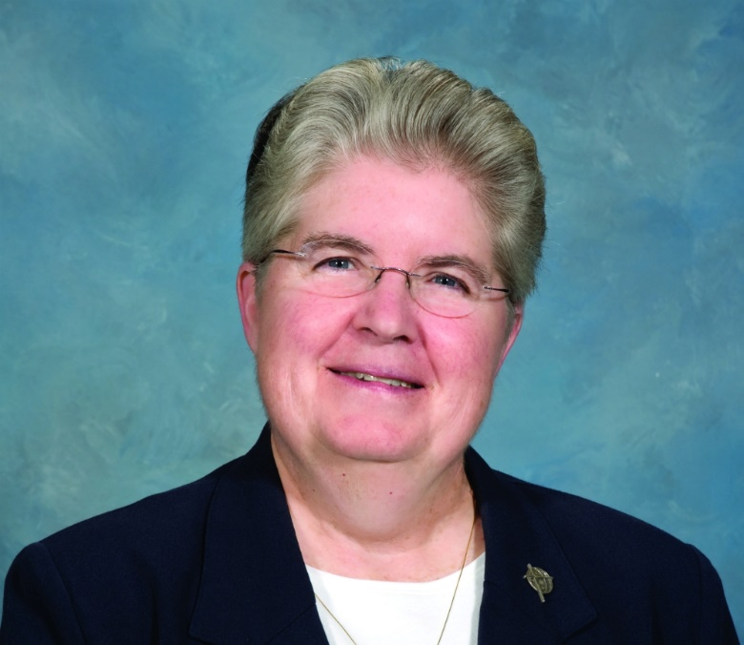

PLEASE RETURN TO Vocations Ireland 36 Cloran Court, Athboy Co Meath C15H2C3

OR EMAIL info@vocationsireland.com CLOSING DATE 03.11.20

NAME OF PARTICIPANT…………………………………………………………………………………………………………………

CONGREGATION……………………………………………………………………………………………………………………………

EMAIL ADDRESS……………………………………………………………………………………………………………………………

COST: €10 payable by cheque, postal order or bank transfer
Bank of Ireland Lower Baggot Street Dublin D02 Y754
Vocations Ireland Current Account 80730176
IBAN IE60 BOFI 9014 9080 7301 76
SWIFT/BIC BOFIE2D
REFERENCE Nov Conf.

