Mercy Day Prayer
September 24, 2020
“How lovely is Your dwelling place, Lord God.” (Ps. 84)

Leader: Let us be still and aware of God’s presence within us and around us.

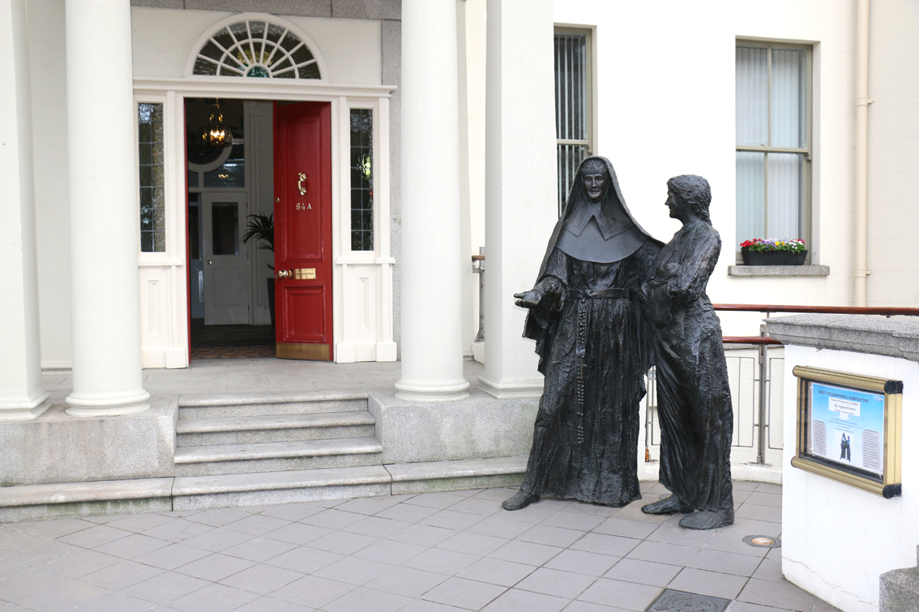

Today we gather at the House of Mercy to remember that on September 24, 1827 Catherine McAuley’s vision to shelter and care for the poor, uneducated women and girls of Ireland took shape in the form of this House. The shelter of this home became a light in a dark time, a source of hope and welcome for the sick and economically poor.
Our lives in Mercy are rooted here, we too belong here. Just as Catherine’s House became spacious enough to shelter all who are in need of Mercy, so too we are called to become a shelter of Mercy, open to all in need. Together we embody this House of Mercy across many lands, mountains and seas.
Once again, our world is faced with darkness and is in need of healing shelter. We join Catherine in trusting in God’s Providence as we seek to receive and offer shelter to our world. Let us continue our prayer, reflecting with the song “Shelter Me” by Michael Joncas.

https://www.youtube.com/watch?v=EPzan_0FDo0&feature=youtu.be

“Shelter Me” – Michael Joncas
- Shepherd and sheep, my God and I:
to fresh green fields you led my steps in days gone by.
You gave me rest, by quiet springs
and filled my soul with peace your loving presence brings.

Refrain: O shelter me, o shelter me:
the way ahead is dark and difficult to see.
O shelter me, O shelter me:
all will be well if only you will shelter me.

- Yet now I tread a different way:
death dogs my path with stealthy steps from day to day.
I cannot find your peaceful place,
but dwell in dreary darkness longing for your face.
Refrain

- I will look back in days to come
and realize your faithfulness has led me home.
Within your house I’ll find my peace,
trusting that in your mercy you have sheltered me.
Refrain
Copyright © 2020 by GIA Publications. All rights reserved. Used with permission.

Quiet reflection questions:
How have I experienced being sheltered? How am I becoming a shelter
of Mercy?

Reading: “Mercy Day” by Mary Wickham, RSM
When we utter aloud the word Mercy,
standing each of us by an open window
anywhere we are in the world,
then the word mercy will carry on the soundwaves
onwards and unceasing,
through the air of the wounded world.
And maybe, when it takes flight
into deed and kindness, justice and effort,
it will effect a healing, a hope and a blessing.
It may call the homeless home,
it may coax to hope the betrayed and broken,
it may ease the burdened earth.
Listen for it, the repeated word mercy on this mercy day.
Listen for its neighbourly dialect and global idiom.
Imagine those who like you are saying it aloud,
and those who need to hear it, today—the word--mercy.
One word, one deed of justice, one kind effort at a time.

Creator God, sustainer of life,
Jesus, our companion Word,
Spirit who, like the air, inspires,
give us the simple daring this day
to say and to be Mercy.

Quiet reflection questions:
What are the qualities of a House of Mercy? During these difficult days, in what ways do I see myself as a House of Mercy?

Sharing of Reflections

Intercessions Response: Shelter us, O God
Within each Mercy heart is a Baggot Street House of Mercy, and as such we pray:
Let us be a house of mercy for everyone who enters where the doors are always open…
Let us be a house of mercy where those who are homeless, wounded and fearful might find healing, acceptance and protection…
Let us be a house of mercy always anticipating the stranger’s need, where justice is tempered with mercy and love in abundance…
Let us be a house of mercy where each guest is greeted by a listening, compassionate heart…
Let us be a house of mercy living reverently in our common home, treating Earth and all her creatures with wonder and respect…

Leader: In communion with one another and in the spirit of Catherine McAuley,
let us sing or recite the Suscipe:

https://youtu.be/4RahGqPWGhM

Adaptation of the Suscipe by Sister Dina Altamiranda, Music by Gisela Palacio,
Sung by Sister Edia Lopez

My God, I am yours for time and eternity.
Teach me to cast myself entirely
into the arms of your loving Providence
with a lively, unlimited confidence
in your compassionate tender pity.

Grant, O most merciful Redeemer,
that whatever you ordain or permit
may be acceptable to me.

Take from my heart all painful anxiety,
let nothing sadden me but sin,
nothing delight me but the hope
of coming to the possession of You,
my God and my all,
in your everlasting kingdom.
Amen.

Closing Blessing

Leader:
May the blessing of this house –
a house imagined in unlikeliness,
dreamt with daring,
built with love,
founded on Mercy,
speak to your spirit in whatever room in the world you are reading,
in whatever place you are called to Mercy.
-Mary Wickham, RSM

All:
Creator God, sustainer of life,
Jesus, our companion Word,
Spirit who, like the air, inspires,
Give us the simple daring this day
To say and to be Mercy.

**During this time of Mercy celebration we encourage one another to visit our House of Mercy on the Mercy International site (mercyworld.org) and to even make arrangements with Anna Nicholls, rsm who is organizing virtual tours of the House of Mercy.**

