~Novena for the Feast of Our Lady of Mercy 2019~

Welcome to the Novena for the Feast of Our Lady of Mercy.

The aim of our Novena is to prepare ourselves for the great Feast: to take pause, to ponder the meaning of the Feast, to look back lovingly and look forward in hope, and to reflect on the life of the woman the Feast honours.
The Outline for each day is the same:

- an artwork that invites our respectful, meditative gazing for what it reveals about Mercy and Mary; each art work expresses a truth, filtered by its artist, its era and its culture.
- a short reflective piece on an aspect of Mary’s life or person, drawing on canonical Scripture, apocryphal tradition and imagination.
- a question for our personal and communal consideration;
- and the formal prayer that links each day

We unite in our prayer as we ponder in our hearts the meaning of the title Mary, Mother of Mercy… Misericordia… Marimari… Trocaire…

Novena Prayer

For this Mercy day,

I will rest in the Word;

I rise with the images of Mercy in my heart.

I aspire to live and give, receive and encounter Mercy, this day and every day,
inspired by Mary who mothered Mercy, and with the help of her Son,
Jesus the Christ of Mercy.

Amen.

Day 1- The Daughter

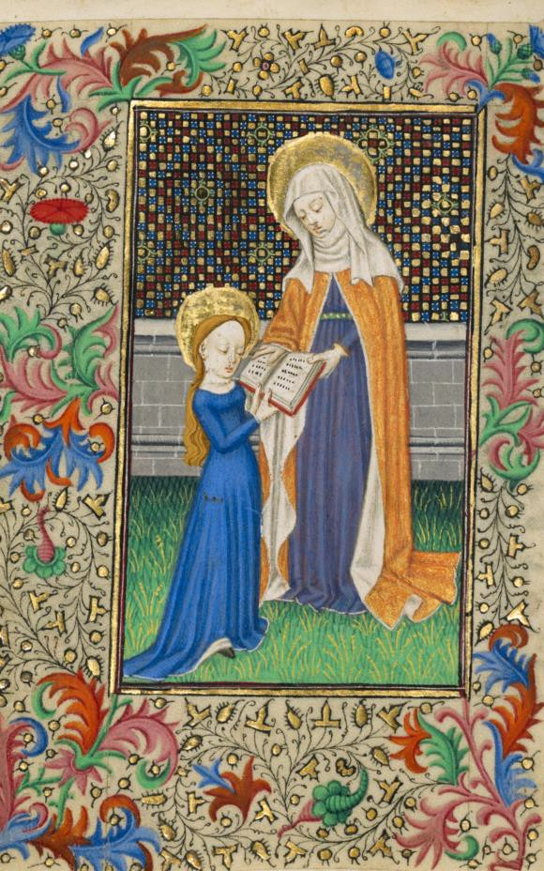
St Anne Teaches the Virgin to Read: Book of Hours, Master of Sir John Fastolf, French, circa 1450.

Before you became an icon in all senses of that word, you were an unremarked girl of Galilee. Before ever you were imagined by the Renaissance painters in the blue regal cloak of honour- because the blue of the ground lapis lazuli was one of the most precious pigments- you were part of a peasant family in a small village. The Christian tradition names your parents as Joachim and Anna. The Muslim tradition honours you and your ancestors. A strong part of that tradition is that you learnt the Hebrew Scriptures at your mother’s hand. You were a daughter of a treasured tradition. The Word of God was always in your heart. What you learnt as a child, the simple and the profound, you would pass on to your own child. You were the cusp- the fulcrum- poised between two traditions.

  - And I reflect on this question today-
What are the traditions I treasure from the past; what traditions am I shaping for the future?

Novena Prayer

For this Mercy day,
I will rest in the Word;
I rise with the images of Mercy in my heart.
I aspire to live and give, receive and encounter Mercy, this day and every day,
inspired by Mary who mothered Mercy, and with the help of her Son,
Jesus the Christ of Mercy.
Amen.

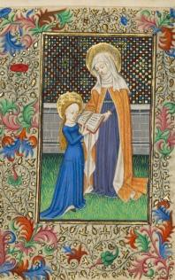

Day 2- The Receiver
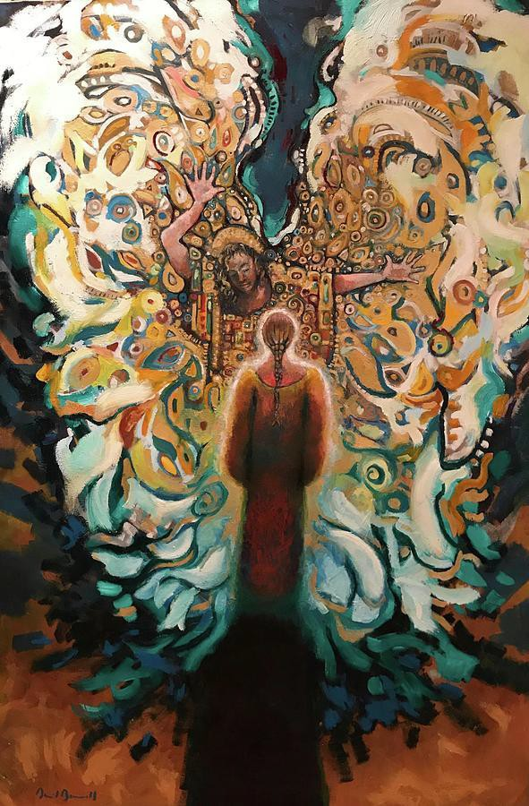

Daniel Bonnell Annunciation 2, Contemporary, USA.

When God’s consciousness met your consciousness the world changed. What frequency were you tuned to in order to receive the Gabriel message? The Word in your heart enabled the Word to flourish in your uterus. When the Spirit of God sends a messenger, life can never be the same. You honoured your capacity as a creature of God by listening and receiving, trusting and surrendering to the paradox you were given. Love and trust were greater than anxiety and natural fear. You believed, against the odds, in a God of Hesed, not of harm, a God of mercy, not menace: God who gave life, for life.

  - And I reflect on this question today:
To what extent am I tuned to life; and what works against that life?

Novena Prayer

For this Mercy day,
I will rest in the Word;
I rise with the images of Mercy in my heart.
I aspire to live and give, receive and encounter Mercy, this day and every day,
inspired by Mary who mothered Mercy, and with the help of her Son,
Jesus the Christ of Mercy.
Amen.

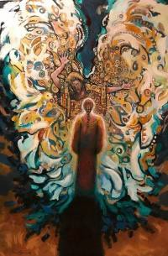

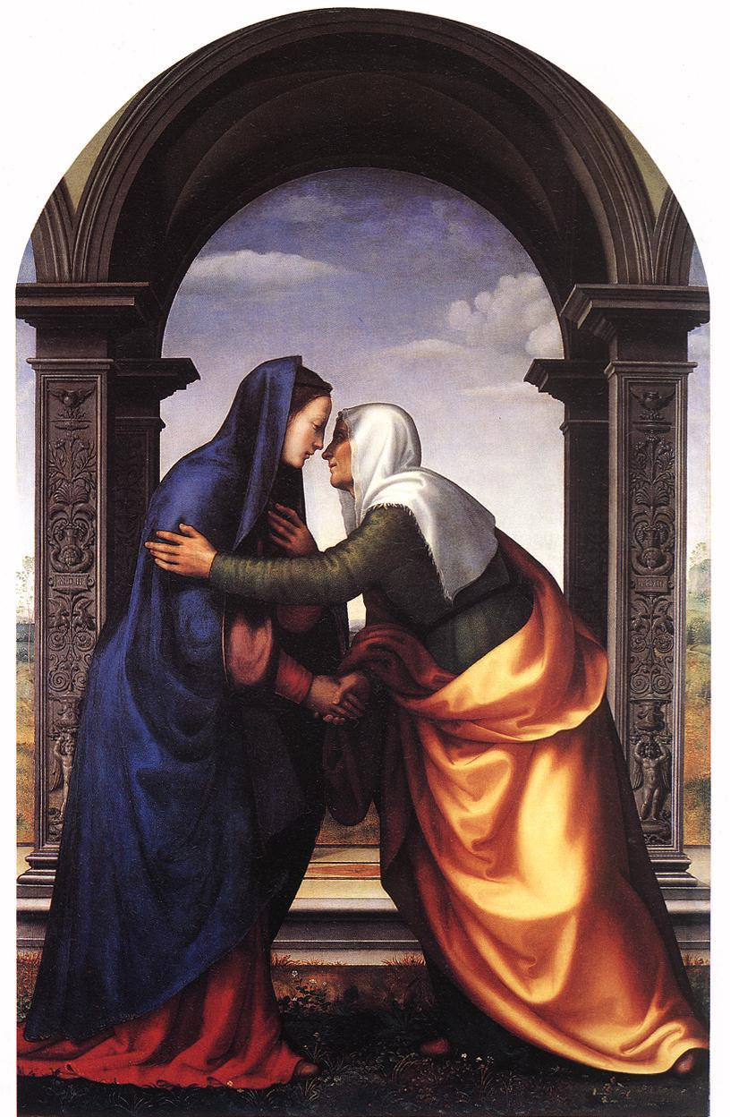
Day 3- The Visitor
Albertinelli, The Visitation, 1503, Uffizi, Florence

The journey you made to Elizabeth was heartfelt and generous. The encounter between you was of mutual empathy, of shared need, of recognition of gifts held and nurtured. Despite the difficulties you were both facing- you socially embarrassed, Elizabeth’s husband struck dumb-the two little lives within leapt for joy. Your cousin reached for poetry to praise your grace. And you, echoing the Psalms and the Prophets, sang - aware of your own mysterious state, aware of the child. You became the first preacher, in your Magnificat, of your child’s “upside down kingdom” the reversal of the predictable ways of the world. This was a meeting of, and a song of, Rahamim, the womb-mercy of God.

  - I reflect today
on relationships of Mercy that have been, and continue to be, significant for me.

Novena Prayer

For this Mercy day,
I will rest in the Word;
I rise with the images of Mercy in my heart.
I aspire to live and give, receive and encounter Mercy, this day and every day,
inspired by Mary who mothered Mercy, and with the help of her Son,
Jesus the Christ of Mercy.
Amen.

Day 4- The Mother

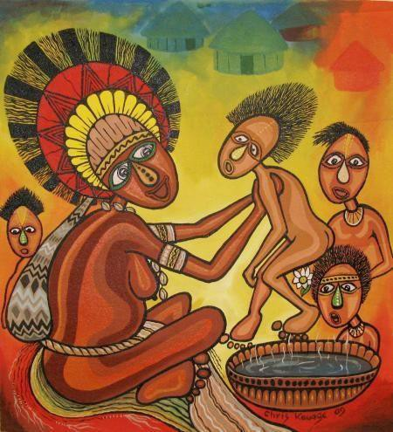

Mama na Pikinini

Chris Kauage, Papua New Guinea, Contemporary

The Greeks have a wonderful word for you as mother- Theotokos- God-Bearer. Whatever the social ignominy of his origin and arrival, whatever the strange company that welcomed him, whatever the lack of homely comforts, surely your intimate mother’s joy was all that mattered when you first gazed at him. No-one else but you shares DNA with Jesus. Did he have your look, your disposition, your eyes and your kindness? It would seem so. Your placenta fed him and led him to being human- the normal nutrients of gestation channelled through your blood to his via the umbilical cord as he sheltered in your uterus.

  - And I reflect today on this question:

In what ways am I and am I not a God-bearer; and who bears God to me?

Novena Prayer

For this Mercy day,
I will rest in the Word;
I rise with the images of Mercy in my heart.
I aspire to live and give, receive and encounter Mercy, this day and every day,
inspired by Mary who mothered Mercy, and with the help of her Son,
Jesus the Christ of Mercy.
Amen.

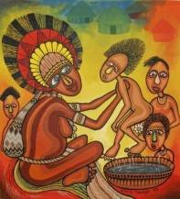

Day 5-The Protector

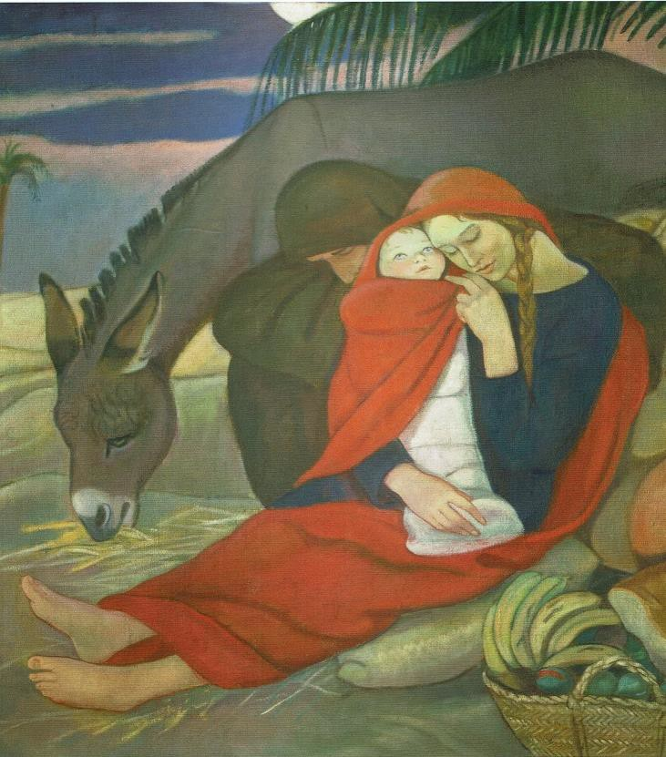

Rest in Egypt (Oasis), Elisabeth Chaplin, c.1927, Palazzo Pitti, Florence

You knew the fierceness of a mother’s protective love. You and Joseph respond to danger, safeguarding the precious child, taking refuge far from home, fleeing to Egypt. You protect one another; sustain one another through the arduousness of the journey. You understand from your own depths the displaced and threatened, the exhausted and the vulnerable. You and your family are of their company.

  - And I reflect today:
how do I seek to protect the vulnerable from danger, and what are the impediments I experience?

Novena Prayer

For this Mercy day,
I will rest in the Word;
I rise with the images of Mercy in my heart.
I aspire to live and give, receive and encounter Mercy, this day and every day,
inspired by Mary who mothered Mercy, and with the help of her Son,
Jesus the Christ of Mercy.
Amen.

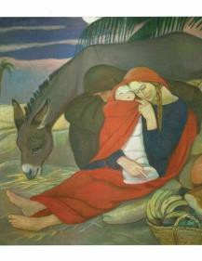

Day 6- The Homemaker and Caterer

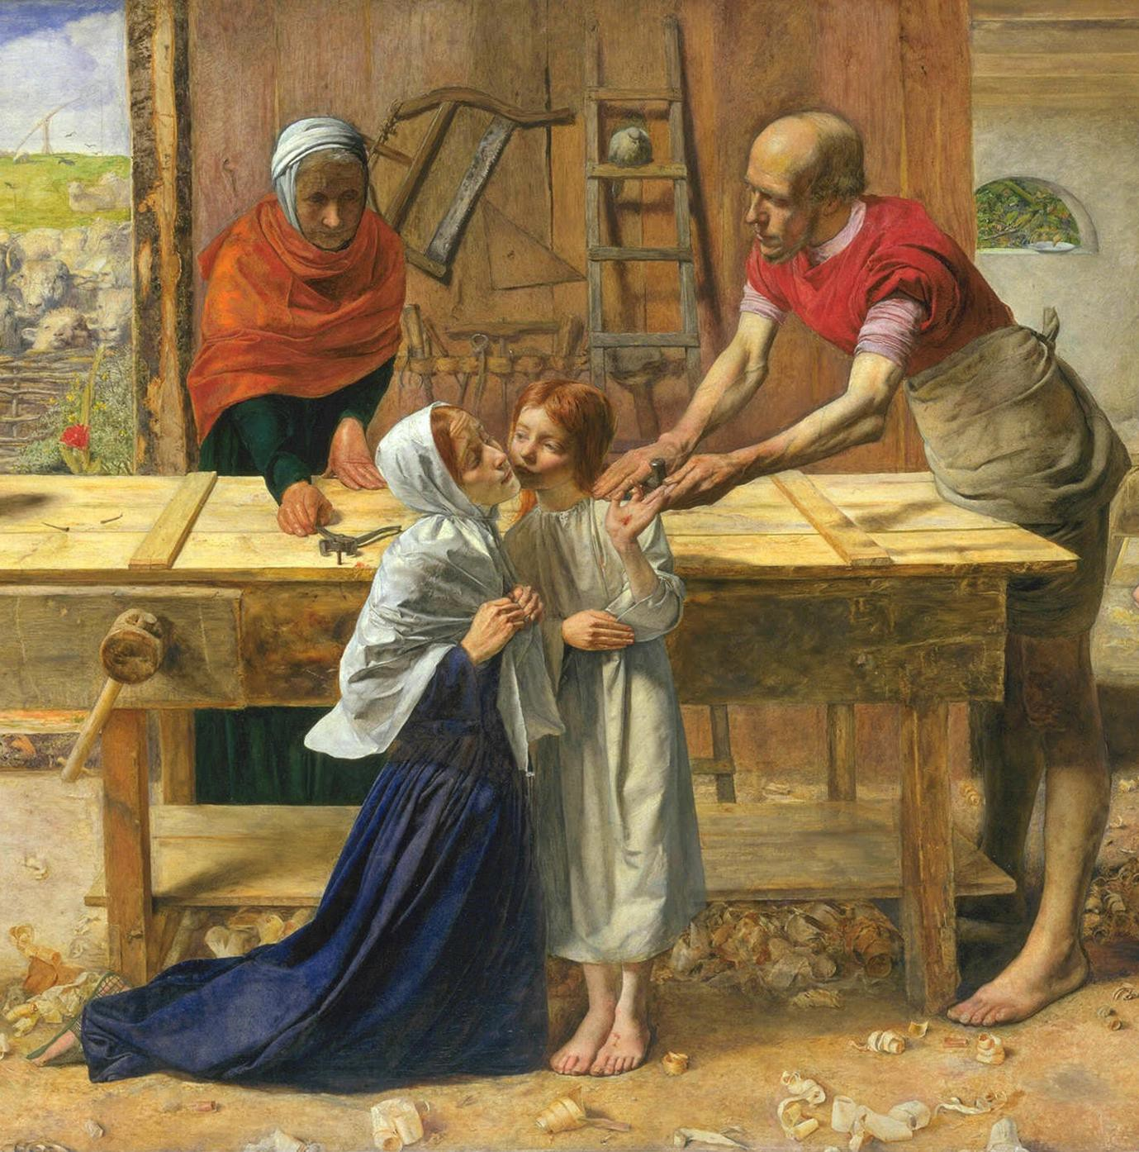

Christ in the House of His Parents (detail), John Everett Millais, 1850, Tate Britain.

There were plenty of ordinary days: cooking and cleaning, washing the sawdust from Joseph’s clothes, showing Jesus how to comb his hair, tending to scratches and ailments, teaching him the courtesies and considerations of life, reciting the Scriptures with him. You made a home for Joseph and Jesus in the ordinary days of peace. You were there too nudging your adult Son to exercise his gift at the Wedding Feast of Cana, not as a party trick but purely to help others. You were there for Pentecost and the Ascension and the law of averages suggests you were at the Last Supper, no doubt providing bread for the table. Why would he not use for the first Eucharist the bread your hands had made? You were there for the ordinary and the extraordinary. You were a nurturer and provider, unassuming yet utterly essential to the humanity of Jesus.

  - And I reflect today:

Who do I nourish, heal and welcome; where am I nourished, healed and welcomed?

Novena Prayer

For this Mercy day,
I will rest in the Word;
I rise with the images of Mercy in my heart.
I aspire to live and give, receive and encounter Mercy, this day and every day,
inspired by Mary who mothered Mercy, and with the help of her Son, Jesus, the Christ of Mercy.
Amen.

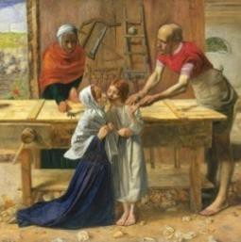

Day 7-The Sufferer

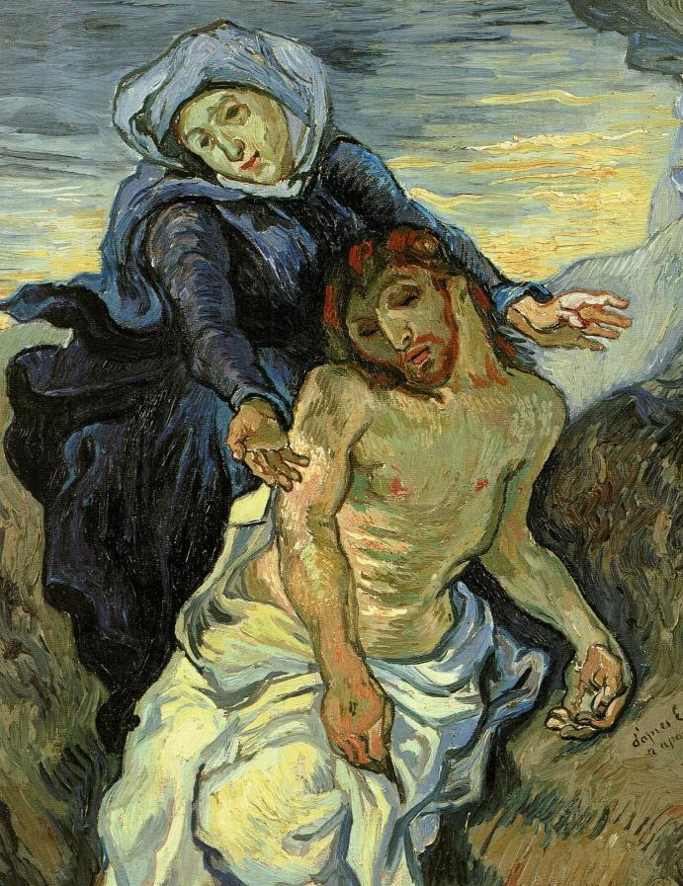
The Pieta (after Delacroix), Vincent Van Gogh, c.1889, Vatican Museums.

Stabat Mater means the standing mother. We see artworks of you standing by the cross, one in spirit with your dying son. We see artworks of you as the Pieta, seated- the twenty four year old Michelangelo made you look serene for Rome; nearly fifty years later the older man knew better when he made another Pieta in Florence, where you look tortured and worn. But essentially you are the standing woman, in every sense of that word: who stood by the cross, stood by your Son, stood by his friends, stood by his values and his beliefs. To take your stand took courage, immense energy and came at great cost. But you stood.

  - And today I ask:
What do I stand for and with whom do I stand?

Novena Prayer

For this Mercy day,
I will rest in the Word;
I rise with the images of Mercy in my heart.
I aspire to live and give, receive and encounter Mercy, this day and every day,
inspired by Mary who mothered Mercy, and with the help of her Son,
Jesus the Christ of Mercy.
Amen.

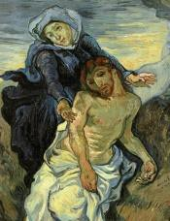

Day 8- The Survivor

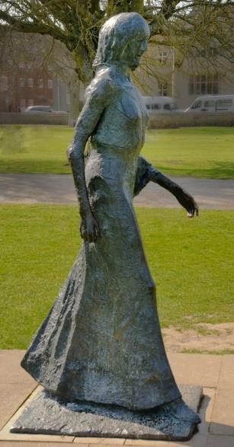

The Walking Madonna, Elisabeth Frink, 1981, Salisbury Cathedral

After the trauma and loss, after the hints of more to the story than the Cross, after the Pentecost ardour, you kept walking. Tradition has it you went with John the Beloved Disciple to live near Ephesus in Turkey. Maybe you did. Perhaps John’s little anecdote about Peter being led where he would rather not go was partly about you too. Widowed, childless, ageing, you became dependent on the kindness of others. Wherever you were, you were a survivor and a bearer of hope, still harbouring in your heart the Word. You are the human being closest in the entire world to God, your boy, Jesus. And you kept walking for him.

  - Today I reflect: Where is my path of survival and hope leading me?

Novena Prayer

For this Mercy day,
I will rest in the Word;
I rise with the images of Mercy in my heart.
I aspire to live and give, receive and encounter Mercy, this day and every day,
inspired by Mary who mothered Mercy, and with the help of her Son,
Jesus the Christ of Mercy.
Amen.

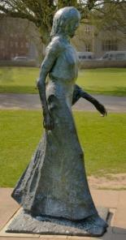

Day 9-The Titled

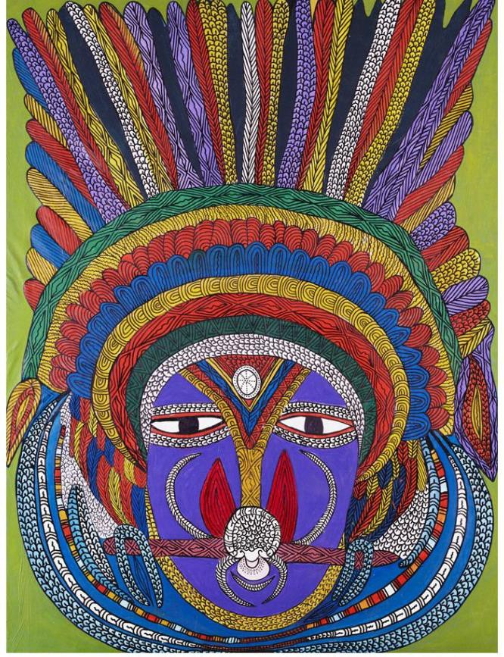

Missis Kwin: A Portrait of Queen Elizabeth the Second

by Mathias Kauage, Papua New Guinea, presented to her in 1996 by the artist.

Just as tradition insists on the extraordinary nature of your birth, so it elevates your death and eternal life to the extra human, beyond our understanding and beyond rationality. We accept the mystery because we accept your sanctity. Each culture possesses its own way to honour those it considers venerable, worthy, of exemplary life. We revere you, girl of Nazareth, for the life you let the Spirit give you. Your titles are many, each of them evocative and inspirational. Today we hold you as Mother, the one who uniquely gives form and life to the quality of God we call Mercy. You are the progenitor of Mercy. Our name is Mercy. Hold us to that.

  - And I reflect today: How does the Mother of Mercy, inspire me today and what is she encouraging me to be?

Novena Prayer

For this Mercy day,
I will rest in the Word;
I rise with the images of Mercy in my heart.
I aspire to live and give, receive and encounter Mercy, this day and every day,
inspired by Mary who mothered Mercy, and with the help of her Son,
Jesus the Christ of Mercy.
Amen.

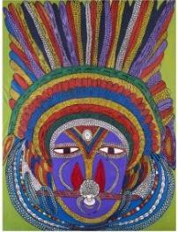

~FEAST DAY BLESSINGS TO ALL~

Prepared by Mary Wickham RSM Institute of Sisters of Mercy of Australia and Papua New Guinea

